Creating a blog using

WordPress Platform

* **Category:** Digital Marketing
* **Skills Required:** Digital Marketing

Team Details:

* A. Bhuvaneshwar
* K. Prasanna
* Siripi Chandu
* Mekala Mahesh

## Introduction:

Creating a blog using the WordPress platform is a popular and user-friendly approach for individuals and businesses looking to share their thoughts, insights, or products with a wider online audience. WordPress offers a versatile content management system that allows you to publish articles, images, and multimedia content effortlessly. It's known for its vast library of themes and plugins, making it highly customizable. Whether you're a seasoned blogger or just starting, WordPress provides a reliable foundation to establish your online presence and connect with your target readership.

# Overview:

Creating a blog using WordPress involves setting up a website to publish content for an online audience. You'll choose a domain name, install WordPress, and customize its appearance and functionality with themes and plugins. Content creation is key, and optimizing for search engines (SEO) helps with visibility. Optionally, you can monetize your blog through advertising or affiliate marketing. Regular maintenance and engagement with your audience are essential for a successful WordPress blog.

# Purpose:

**Sharing Knowledge and Expertise:** Use your blog to share your expertise, insights, and knowledge on topics of interest. Educate and inform your readers while establishing yourself as an authority in your niche.

**Content Marketing:** Blogs are powerful tools for content marketing. They allow businesses to create and share valuable content to attract, engage, and retain customers. This can lead to increased brand awareness and customer loyalty.

**Personal Expression and Creativity:** Blogging provides an outlet for personal expression. Whether it's sharing personal experiences, creative writing, or artistic endeavors, a blog allows you to express yourself to the world.

**Community Building:** Build a community around your blog. Engage with like-minded individuals, foster discussions, and create a sense of belonging among your readers. This is especially valuable for niche communities.

**Monetization:** Many bloggers use their WordPress sites to generate income through various methods, such as ads, sponsored content, affiliate marketing, or selling digital products. A blog can be a source of passive or active income.

## Problem Definition and Design Thinking:

**Empathy Map:**

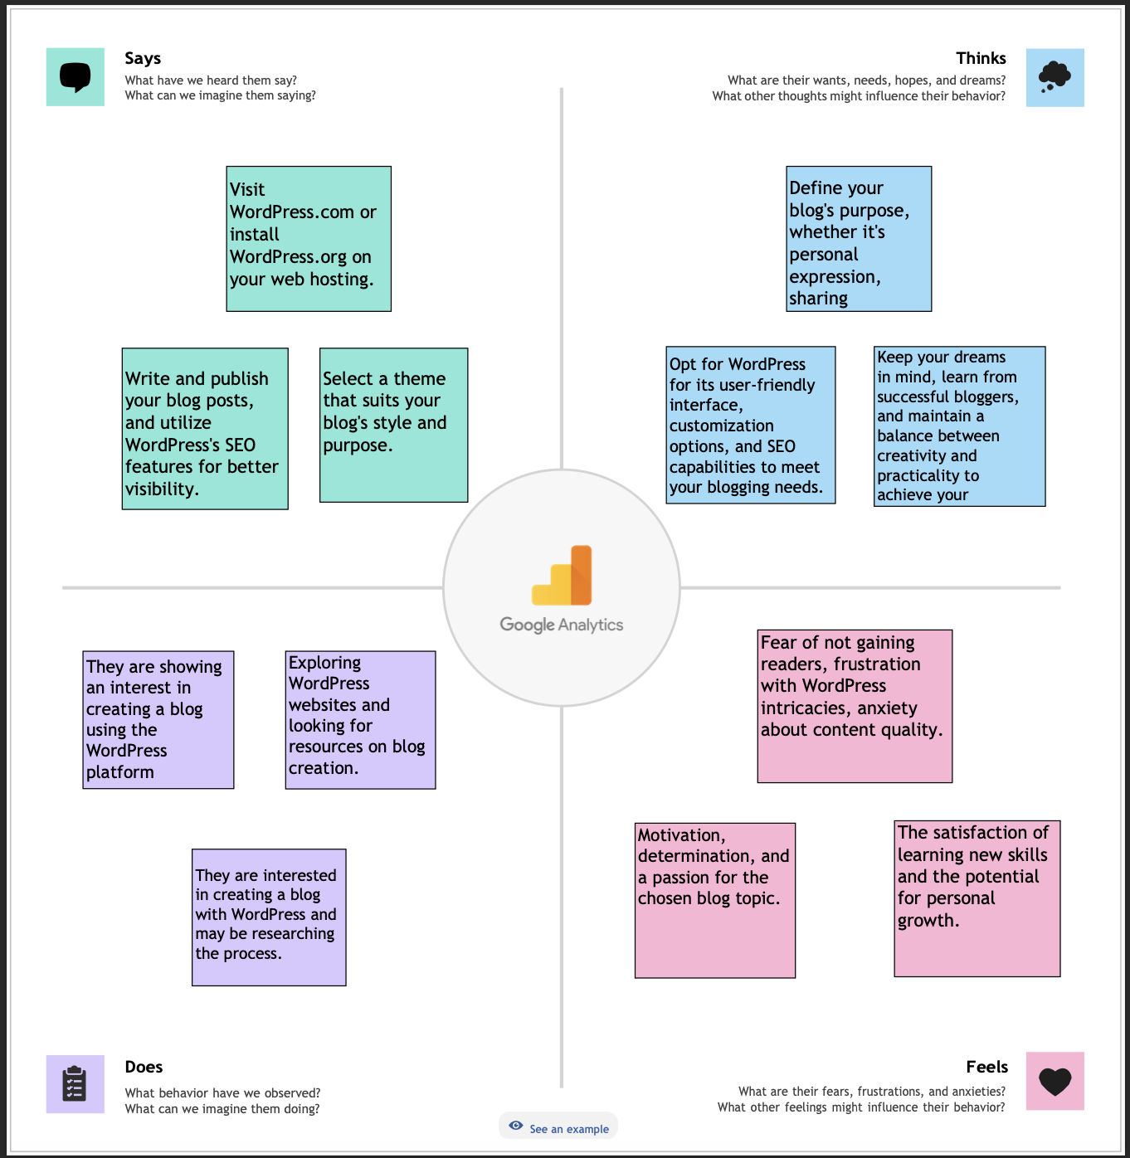

**Ideation & Brainstorming Map:**

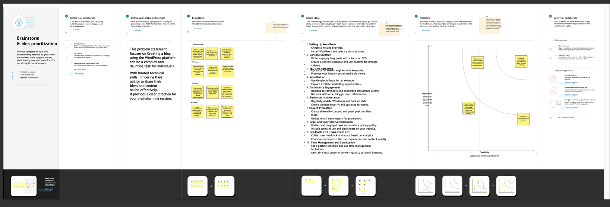

# Result:

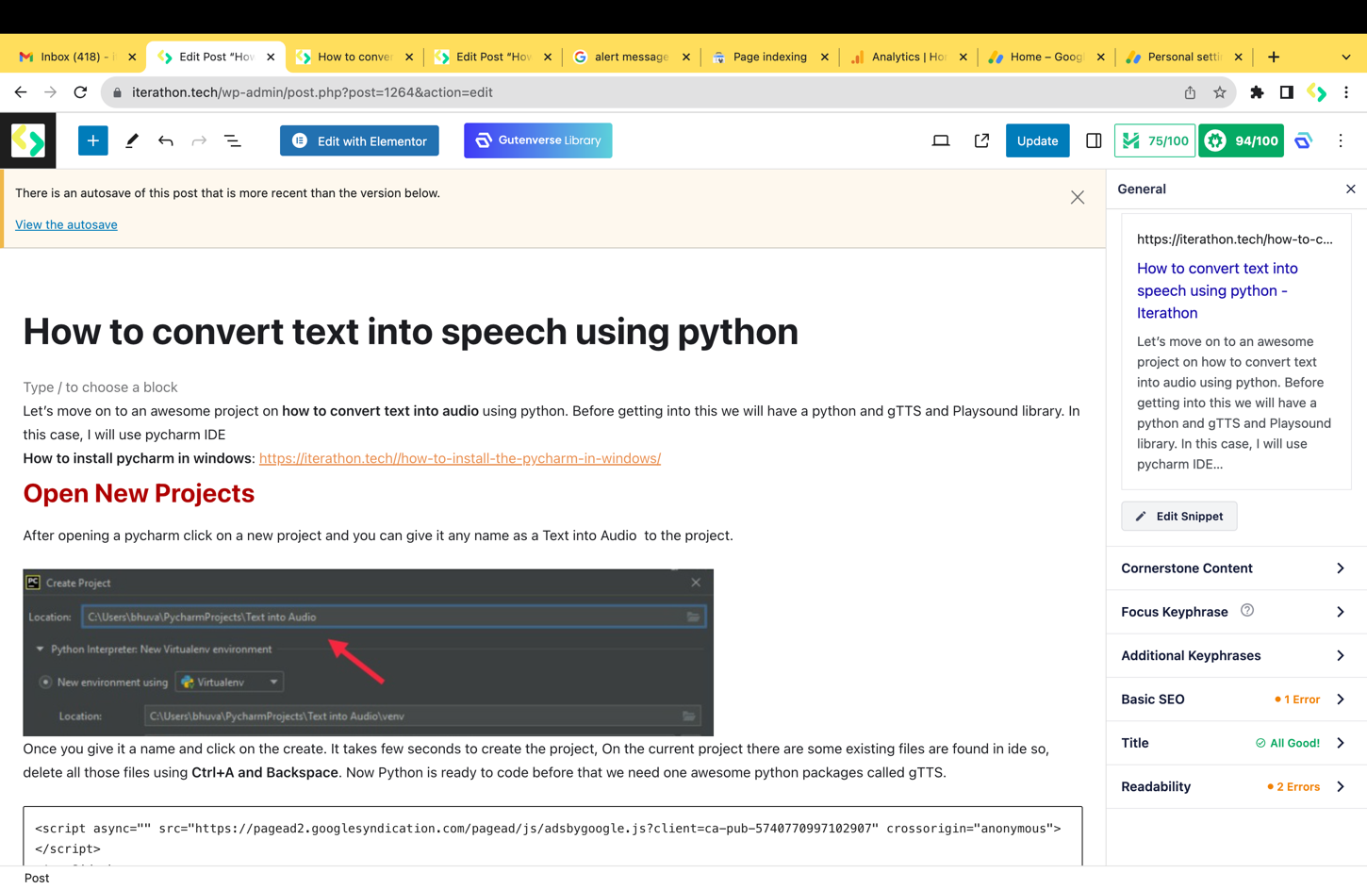

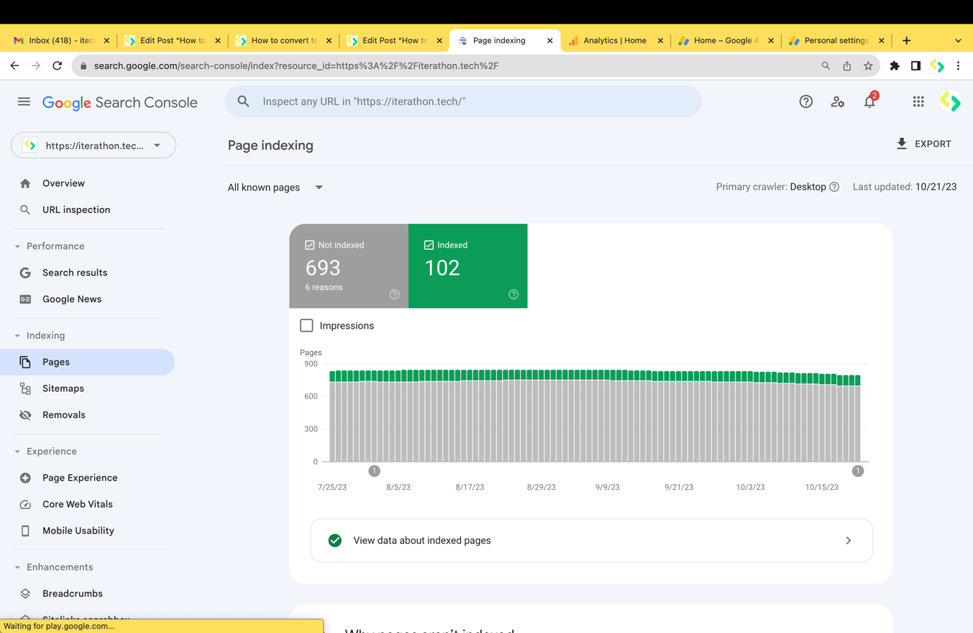

## Advantages and Disadvantages:

### Advantages:

**User-Friendly:** WordPress is known for its user-friendly interface, making it accessible to beginners with little technical knowledge.

**Customization:** It offers a wide range of themes and plugins, allowing you to customize the design and functionality of your blog to suit your needs.

**SEO-Friendly:** WordPress is inherently search engine-friendly, and there are many SEO plugins available to help improve your blog's visibility in search results.

### Disadvantages:

**Learning Curve:** While it's user-friendly, there is still a learning curve, especially for those new to blogging or website management.

**Maintenance:** Regular updates, backups, and security monitoring are necessary to keep your WordPress blog secure and running smoothly.

**Security Concerns:** WordPress is a common target for hackers, so you must be vigilant about security and use reputable plugins and themes.

## Applications:

Creating a blog using the WordPress platform enables individuals and businesses to establish a powerful online presence. This versatile platform offers user-friendly content management, making it accessible for beginners while allowing for extensive customization through themes and plugins. With inherent SEO features, WordPress helps improve your blog's visibility in search results. Its large and supportive community provides resources for troubleshooting and growth. Whether for personal expression, content marketing, or community building, WordPress serves as an excellent choice for achieving diverse blogging goals.

## Conclusion:

In conclusion, creating a blog using the WordPress platform is a strategic choice for anyone looking to share their thoughts, expertise, or products with a global audience. Its user-friendliness, customization options, and SEO benefits make it a top pick. While there are challenges like security concerns and the need for regular maintenance, the advantages far outweigh the disadvantages, making WordPress a powerful tool for bloggers and businesses alike.

## Future Scope:

The future scope for creating a blog using the WordPress platform is promising. As technology evolves, WordPress continues to adapt, offering new features and improved performance. With the growing importance of online presence, blogs will remain essential for individuals, businesses, and content creators. We can expect even more advanced customization options, improved SEO tools, and enhanced security measures to meet evolving needs. Additionally, WordPress is likely to integrate better with emerging technologies, further expanding its role in the digital landscape.